


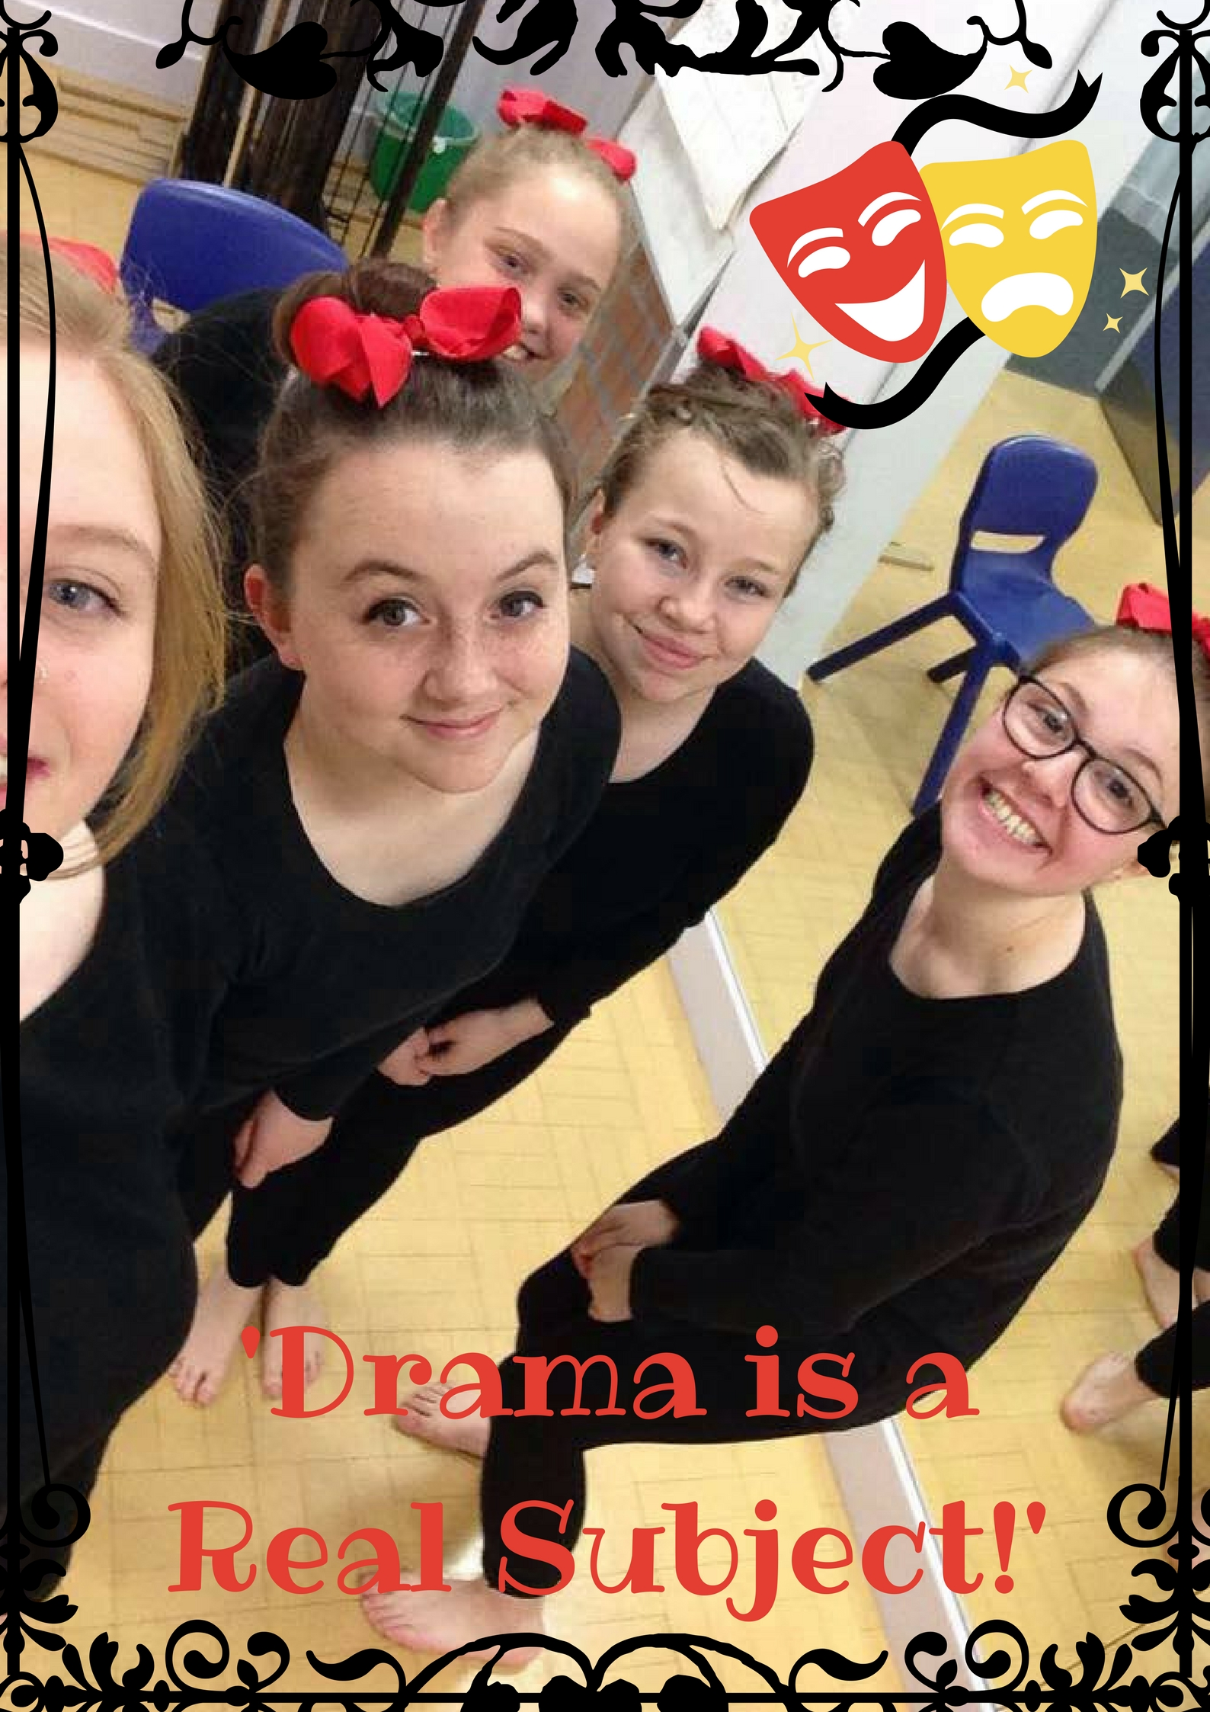
About the Playwright

Grace Bottrill is a creative writer based in the East Midlands, United Kingdom. She is available to write television scripts, stage plays, spoken word poetry or stand alone monologues for performances and festivals across the country. She has written pieces that have been performed by herself and other students at De Montfort University. Drama is a Real Subject is her second play.

Contact Details

Email: graceeliza0110@gmail.com
Drama is a Real Subject is a short play written for the purpose of The Gossip Festival in 2017. The play is based entirely on the real life experiences Grace Bottrill endured during her own A-Level Performing Arts class, and the message of fighting to save arts in education.

The Slade College of Performing Arts is a bit like one of those Ofsted special measures schools, that tries to tart itself up with a posh new name and academy status. One teacher goes over and beyond to worsen its reputation even more.
Elouise, Phoebe, Gabrielle, Amber and Ceri are excited at the prospects of a new teacher to improve their A-Level results. So is Miss Grovenor, their new teacher. Unfortunately, she has no idea what she’s doing.
From random masks to a 10 second warm up, complete with high heels and fur coats galore, Miss Grovenor’s primary school drama class with A-Level students is sure to make you cry with nervous laughter.
​
​

Drama is a Real Subject
A mini satire play by Grace Bottrill
Completed August 2017

