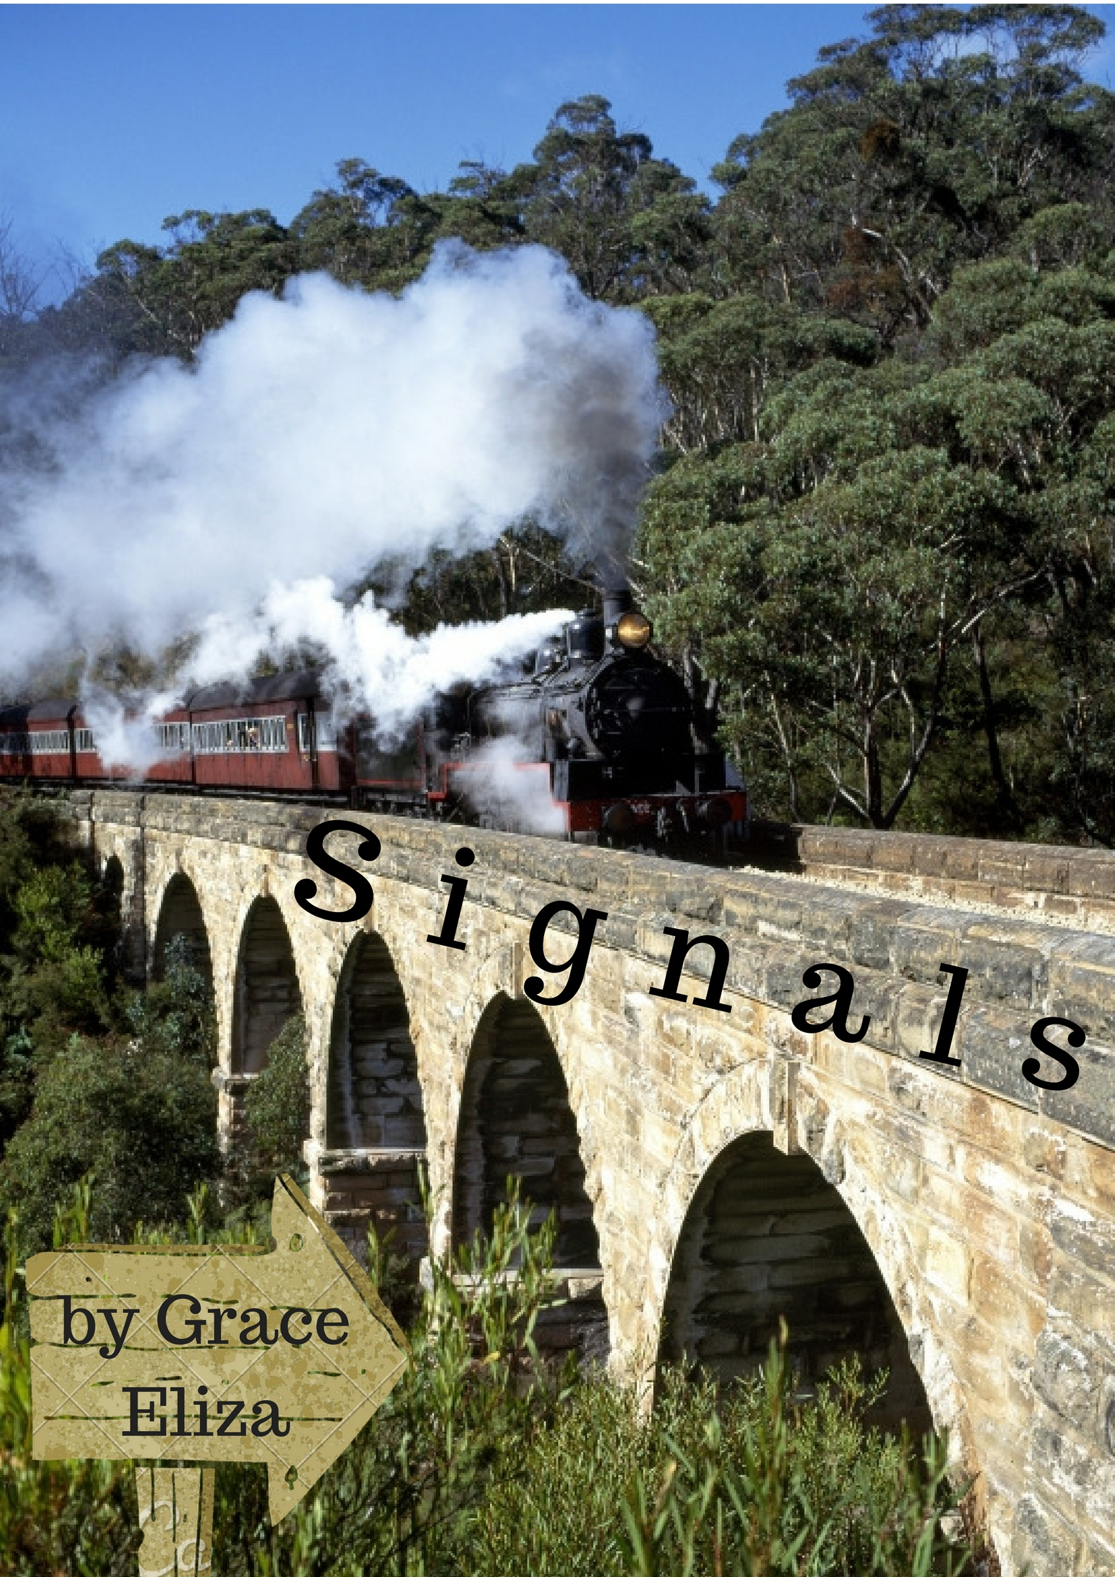

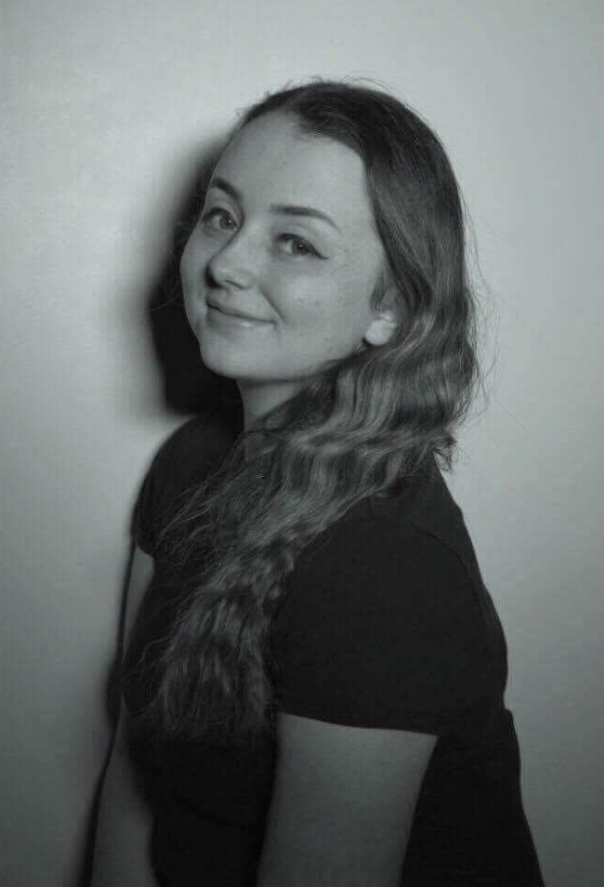

Signals is a play written in a non-linear structure, which jumps throughout the three decades of the cousins’ lives. The play came about whilst Grace was devising a piece of a similar nature at college, entitled ‘REvolution’, and envelops many issues that are still relevant in society today.

​In the sixties, Kathleen is blonde and beautiful. She idolizes Cilla Black. She starves herself every day.
​In the seventies, Phylliss is smart and selfless. She adores The Carpenters. She’s bullied by those who are supposed to be her friends.
​In the eighties, Kenny is a huge personality and a talented singer. Whitney is his heroine. He struggles to come to terms with his sexuality.
The three cousins constantly experience prejudice and abuse daily, because they are simply being themselves. But through courage and growth, they hope to come out of it okay. That’s just how growing up works.
​

Email: graceeliza0110@gmail.com
About the Playwright

Grace Bottrill is a creative writer based in the East Midlands, United Kingdom. She is available to write television scripts, stage plays, spoken word poetry or stand alone monologues for performances and festivals across the country. She has written pieces that have been performed by herself and other students at De Montfort University. Signals is her debut play.

Signals
A play by Grace Bottrill
Completed July 2016
Contact Details

